CRS Direct EB Digital Service
Version 1.0

Table of Contents
1 Overview 3
2 Business Purpose 3
3 Architecture 3
3.1 Service Topology Diagram 4
4 Security 4
5 CAD EB 150 Quote API 5
5.1 Request Message 5
5.2 Request Validation 6
5.3 Response Message 7
6 Exception Handling and Recovery 8
7 How to Test 8
8 Document Revision History 9

Overview
Hartford Steam Boiler (HSB) is constantly expanding its portfolio of system to system digital integration options. Our API services are hosted on Microsoft’s Azure Cloud. This document contains information for Hartford Steam Boiler clients to digitally integrate with the Custom Risk Solutions’ Equipment Breakdown product.

Business Purpose
As part of Custom Risk Solutions Digital strategy, we have built an extensive set of digital services for our customers to embed into their workflow. We will be providing complete rate, quote, bind and issue capabilities via APIs to support new business transactions. This would also include the generation of all necessary documentation and the digital delivery of the said documentation.
For Equipment Breakdown, we will provide the following capabilities
- Digital delivery of a Quote based on the submission data provided by the customer if submission meets our appetite.
  - In the event where submission exceeds our appetite, the submission will be referred to the HSB Underwriting team for further evaluation.
- Digital delivery of all relevant documentation pertaining to a Quote (where applicable)
- Digital Bind of a previously created Quote.
- Digital Policy Issuance and delivery of all relevant documentation pertaining to the Policy (where applicable)

Architecture
HSB has built a secured cloud Application Program Interface (API) to provide information related to CRS Direct EB Digital Service API.
API’s are available through Secure Cloud with various security options, see section 4 for information.

Service Topology Diagram

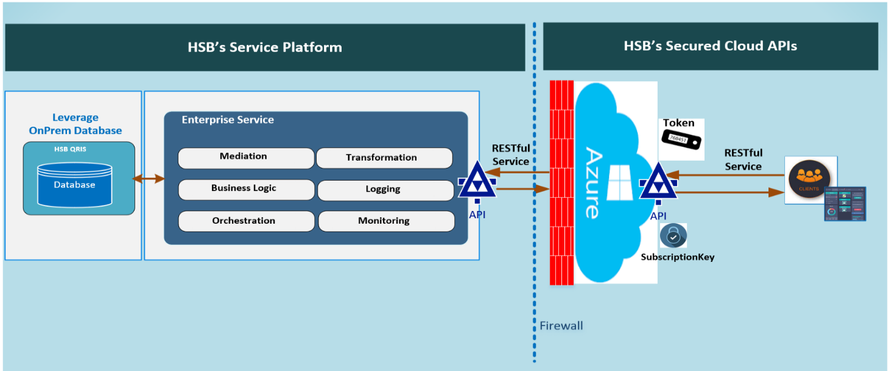

Security
Access to HSB’s API products begins by obtaining a subscription account, and then enable your API module for that account. An API account can be coordinated through HSB’s integration team:
HSBIntegrationTeam@hsb.com
HSB utilizes Microsoft Azure’s API Management tool for exposing internal APIs to external Client Companies by applying two security/authentications to the HSB API (internal) and access the API from the Internet (external):
Security Level 1: URL and HSB provided Subscription Key,
Security Level 2: URL and HSB provided Subscription Key plus OAuth2 Token/certificate.

CRS Direct EB Digital Service Quote API
This service allows an external system to create Quote.

Request Message

Type | SubType | Field | Required | Format | Description
producerDetails |  | producerCode | Y | 7 digit Numeric | Producer Code
insuredDetails |  | insuredName | Y | Alphanumeric | Name of Insured Company or Person
insuredDetails | mailingAddress | line1 | Y | Alphanumeric | Mailing address of the Insured
insuredDetails | mailingAddress | line2 | N | Alphanumeric | Mailing address of the Insured
insuredDetails | mailingAddress | city | Y | Alphanumeric | Mailing City of the insured
insuredDetails | mailingAddress | stateCode | Y | 2 Alphabets | Mailing State of the insured
insuredDetails | mailingAddress | postalCode | Y | 5 digit Numeric | Mailing postal code of insured
insuredDetails |  | effectiveDate | Y | YYYY-MM-DDT24:60:60 | Policy Effective Date
insuredDetails |  | expirationDate | Y | YYYY-MM-DDT24:60:60 | Policy Expiration Date
insuredDetails | eligibilityQuestions | questionId | Y | Alphanumeric | Question Serial Number
insuredDetails | eligibilityQuestions | questionText | Y | Alphanumeric | Question
insuredDetails | eligibilityQuestions | answer | Y | Alphanumeric | Answer (Yes/No)
locationDetails | location | locationId | Y | Numeric | Location Serial Number
locationDetails | location | locationName | N | Alphanumeric | Location Name
locationDetails | location/buildingDetails | buildingId | Y | Numeric | Building Serial Number of a Location
locationDetails | location/buildingDetails | buildingName | N | Alphanumeric | Building Name
locationDetails | location/buildingDetails | naics | Y | Numeric | NAICS Code for Building
locationDetails | location/buildingDetails/mailingAddress | line1 | Y | Alphanumeric | Mailing address of the Building
locationDetails | location/buildingDetails/mailingAddress | line2 | N | Alphanumeric | Mailing address of the Building
locationDetails | location/buildingDetails/mailingAddress | city | Y | Alphanumeric | Mailing City of the Building
locationDetails | location/buildingDetails/mailingAddress | stateCode | Y | 2 Alphabets | Mailing State of the Building
locationDetails | location/buildingDetails/mailingAddress | postalCode | Y | 5 digit Numeric | Mailing postal code of Building
locationDetails | location/buildingDetails/valuationDetails | building | Y | Numeric | Building Valuation Amount
locationDetails | location/buildingDetails/valuationDetails | contents | Y | Numeric | Building Content Amount
locationDetails | location/buildingDetails/valuationDetails | businessIncome | Y | Numeric | Building Business Income Amount
locationDetails | location/buildingDetails/valuationDetails | perishableGoods | N | Numeric | Building Perishable Goods Amount

Request Validation
Requests that do not contain elements marked as “Y” will generate a failure response from the API. See Section 6 for details regarding Exception Handling and Recovery.

Response Message

Type | SubType | Field | Description
status |  | status | Status of transaction
statusCode |  | statusCode | Status Code
message |  | message | Description of transaction status
data |  | requestType | Type of Request
data |  | requestReference | Quote Number
data |  | dateCreated | Date and time stamp from carrier's system
data |  | annualPremium | Annual Premium Amount
data |  | totalTransactionTax | Tax Amount on Premium
data |  | totalTransSurcharge | Surcharge Amount on Premium
data |  | totalTransactionPremiumTaxSurcharge | Total Premium including Tax and Surcharge
data | deductibles | biDeductibleType | Business Income Deductible Type
data | deductibles | biDeductibleValue | Business Income Deductible Amount
data | deductibles | pdDeductibleValue | Property Damage Deductible Amount
data | deductibles | spoilageDeductiblePercent | Spoilage Deductible Percentage
data | coverageData | coverage | Description of available coverage
data | coverageData | value | Limit for the available coverage
data | coverageData | isIncluded | Coverage included in Policy or not (Y/N)

Exception Handling and Recovery
Below is list of exception codes and respective descriptions:

Status Code | Status | Status Description
HSBRT0000 | Success | Success
HSBRT0001 | Failure | Field {0} is missing please correct.  If any of the required field is missing in request, then this error message will be returned in response.
HSBRT0002 | Failure | Field {0} data is invalid please correct.  If invalid value is given for any of the parameter in request, then this error message will be returned in response.
HSBRT0003 | Failure | Record {0} not found.  If incorrect data (that is not present in DB e.g. Producer Code) is given in request, then this error message will be returned in response
HSBRT0004 | Failure | Token ID is invalid. Please correct and try again.
HSBRT0351 | Failure | System failure. Please call 1-877-673-5888

How to Test
Recommended Testing Tool
- Postman
Service URL:
Quote Request
https://hsbapidev.azure-api.net/hsbcrseb/api/v1.0/GetRate?token=XXXXXXXXXXXX
** Subscription Key/Token will be provided separately
** Service URL will be provided separately for testing environments.

Sample Request & Response:
Quote

Sample Postman Collection:
Will be sent separately.

Headers
Quote
    - Content-Type: application/json;
    - token

Document Revision History

Version | Date | Updated By | Revision Description
1.0 | 11/10/2024 | Saket Saraf | Created and Updated.

